Nepal College of Information Technology
Unit Test
Fall 2013
Program : BE_IT_Morning Time : 2 hrs
Semester : (I) FM : 70
Subject : Engineering Math-I PM : 35

- Candidates are requested to give their answer as far as practicable in their own words.
- The figure in the margin indicates the full marks
- Attempt ALL question

1. a. If a function f (x) is derivable at a point x = c. Show that f(x) is continuous at x = c. By taking suitable example show that the converse may not be true. (7)
b. State and prove Cauchy Mean value theorem. Also verify Cauchy Mean value theorem for f(x) =x, g(x) = 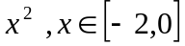 (8)
2. a. Evaluate 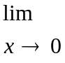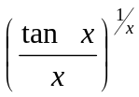 (7)
b) Show that the semi-vertical angle of the cone of maximum volume of a given slant height is tan⁻¹(). (8)
3. Integrate (any three) (15)
i) 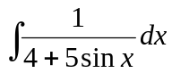 ii) 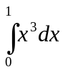 ( by the method of summation)
iii) 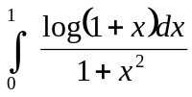 iv) 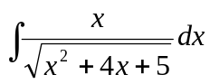
4. a Define asymptotes of a curve. Find the asymptotes of y³ + x²y + 2xy² – y + 1 = 0 (7)
OR
Find the area bounded by the parabola x² = 4y and the curve y = 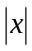
b. If 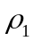and 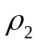 be the radius of curvature at the ends of Latus rectum of the parabola y² = 4ax, prove that 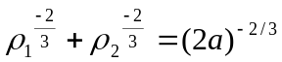 (8)
OR
State Leibnitz theorem for successive derivative of the product of two functions. If y = (sin⁻¹ x)², prove that (1 – x²)y₂ – xy₁ – 2 = 0 and hence show that (1 – x²)y_{n+2} – (2n +1)xy_{n+1} – n²y_{n} = 0.
5. Attempt any two (2*5 = 10)
a. If 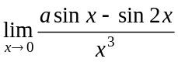 is finite, find the value of 'a' and the limit.
b) 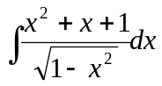
c) 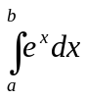 (by summation method)

